Laser Harp
Luke N. Goodman (lng26@cornell.edu), Mary Regan (mer278@cornell.edu),
Kelly Li (kl836@cornell.edu)

INTRODUCTION

Our group built a laser harp prototype in which lasers represent strings on an instrument and interrupting a beam represents strumming a string. This project aims to build an interesting modern instrument for musical and entertainment purposes. Upon breaking the flow of one of 7 beams of light, a musical sound corresponding to the beam interrupted is produced. Each “string” requires a range sensor and light beam, and to improve the effectiveness of the harp, we will recommend wearing white gloves (provided by our team), which increase reflectivity by a significant margin. This will incorporate lasers, light sensors, MIDI conversion and software, and, of course, an Arduino program that takes the data from the sensors and translates it into MIDI signals in real time. In a time of EDM concerts, laser light effects, and synthesized music, instruments like these have the potential to improve the live music entertainment experience. We can even “tune” the harp to produce different sounds corresponding to a variety of instruments as well as can change modes to have the harp act as a teacher to the user.

FINAL PROTOTYPE DEMO VIDEO
https://youtu.be/hLWpux3BKfI

RELATED WORK

There are currently a wide variety of laser harps in existence, with a wide range of complexities. Our work intends to draw on aspects of many of these harps, as well as other Arduino musical instruments to create a unique product. The most basic laser harp we found on the Instructables website consisted of laser sources and light detectors (photoresistors). Each laser source is paired with a light detector, which detects the light level and sent signals to the Arduino monitor. When player’s hand interrupts the laser beam, the monitor creates MIDI data and sends it to the synthesizer to produce music notes. This implementation gave us the basic idea of how the laser harp works, and we will build our laser harp based on this concept.
For more advanced versions, we found that there are two types of laser harps: framed and frameless. The harp mentioned above is an example of framed laser harps. The framed laser harp requires multiple photoresistors to be inside the upper or lower frame of the harp. It uses low-powered lasers, usually 5 mW, which is not quite visible in normal air and bright environment (and would require a type of fog or mist).

The frameless design requires a single high-power laser. The laser beam is split into a fan of beams, and each beam corresponds to a particular note. It only requires one photoresistor that detects the reflected beam and then determines which beam the player interrupts. However, the higher-power laser required can be harmful for the eyes and skins. Therefore, for our project, if we follow the frameless design, we will need to wear appropriate glasses and gloves or choose a safer laser, and we also need to make sure it’s safe for use with the kids at the Science Center. If we follow the framed design, we need to think about how to make the laser more visible in a normal air/light condition.

In addition to the existing laser harps, we did research on other musical instruments that involve Arduino or lasers to gain more scope and perspective on how to improve the current model. We found that most of the existing laser harps and other Arduino musical instruments do not have the feature of modulating the sound when the hand is closer or further away from the detector. They can only sense changes if there is a touch or an interruption. Even if they do change the pitch of the sound, they cannot change its volume according to how fast or slow the player plays it. However, there are products on the market that do this. For example, in the “Air Guitar” project, the player produces different pitches of sound by changing the distance between his hand and the detector. Drawing from this project, we decided to add the feature that enables players of our laser harp to change the pitch and volume of a note. We are also including the ability to switch between a variety of sound packs with the emulation of different instruments as in the “Coke Piano and Launchpad” project, which allows the user to change sound packs by touching one of several aluminum cans. Another thing that the existing laser harps and Arduino musical instruments lack is the ability to produce harmonies which we would like to implement as well.

DESIGN OVERVIEW & BUILD
- Range sensors
  - The range sensors we are ordering are sensitive to ambient light up to approximately 1.5 feet. Their purpose is to receive range/laser interruption input for each harp “string” and provide that data to our Midi controller. We chose to include eight of them to represent each musical octave. There will need to be a distance constraint placed on the range sensors so that they do not play sounds constantly upon sensing the upper frame.

- MIDI controller software (“vmpk” and “hairless”)
  - Using these two softwares we were able to generate midi events (“vmpk”) and create a serial bridge using wifi to transmit these events to the arduino (“hairless”). This allowed us to translate our range data into a variety of musical sounds.

- Box:
  - The box contains the sensors, breadboard, and wires. Not only will it protect this delicate components, but it will also hold them in place. Because the range sensor will be activated by any object that enters its path it is very important that it remains fixed in its place. There are 7 holes in the lid for each of the 7 sensors and lasers, as well as a small hole in the side to allow wire access for the Arduino photon and the other outer components. Much like our jack in the box project, we laser cut our final casing by making several fitted sides. The box was bound together using simple notches as well at t-cuts. Initially, we planned to create a solid box, but found it was easiest to access and adjust the wires and sensors by having a separate top piece (all sides except the bottom) fixed solidly together and use notches to stabilize this to the bottom piece (which the breadboard was attached to.
- Frame:
  - The frame serves two purposes: to limit the motion of the user to a distance the range sensor can sense, and to hold the lasers. The sensors we are using are effective up to a distance of about 40 cm. Therefore the final design will have a frame that is roughly this height, in relation to the top of our box casing (it should be noted that our low fidelity prototype has a frame smaller than this for convenience and stability purposes with the cardboard). The frame also serves aesthetic purposes. We intend to laser print a frame that makes the design look like a musical instrument.

- Lasers
  - The lasers serve as the main user interface. They indicate to the user where they can interact with the instrument to produce music. They present an aesthetic appeal as well as functional purpose in representing the familiar interface of a stringed instrument. They also prove useful as a “music instructor” in Tutorial Mode.

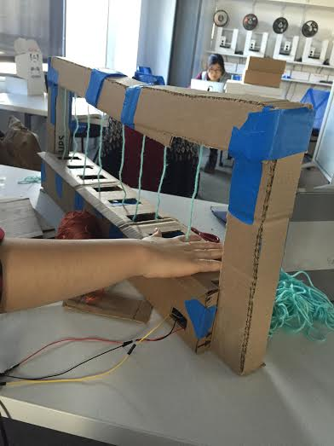
Low-fidelity cardboard design, strings representing lasers.

KEY FEATURES OF THIS PROTOTYPE
- Seven Strings and Free Play Mode
Free Play mode is the default mode of our laser harp. In this mode, the users can play one note in the C major scale each time they interrupt the laser beam. Multiple beams can be interrupted to play a harmony.
- Range sensors:
  - In the stage of developing the low fidelity prototype, we had some issues with the range sensors we ordered, so we decided to switch to the range sensors in our kits. We implemented 3 sensors for the low fidelity prototype. Each sensors would generate serial outputs and send them to the photon when the beam is interrupted, then the photon sends the serial message to the MIDI converter. Originally, we wanted to have each string to represent one musical octave, so the users can play different notes when moving their hands along the laser beam and different scales when moving their hands across different beams. We implemented this idea by controlling the “pitchbend” message, which is a MIDI message used to change the pitch of the notes that are playing. However, the pitchbend did not perform as well as we wanted . It would not play the correct note. For example, it was supposed to play C when the hand interrupted the beam at a certain position, but it would play C# instead. So we think it would be more intuitive for the users to play one note or one harmony at a time by sticking each string.
  - For the final prototype, we implemented seven sensors, and each sensor represents one note in the C major scale. We tested them to make sure that each sensor can sense the interruption and sends the correct message to MIDI converter for the corresponding note.

- Lasers:
  - For our low fidelity prototype, we didn’t use any lasers because our order got stucked in China, but for the final prototype, we were able to use seven red laser diodes to indicate where the users can interact with the instrument and produce music.

- MIDI converter:
  - Originally, we wanted to use the MIDI adapter and converter that allow us to translate our range data into a variety of musical sounds. However we decided to replace the MIDI adapter and converter with a free software called “Hairless Midi Serial”, which takes the serial signal from the photon through wifi, converts the signal, and sends it to the MIDI synthesizer. By using this software, we were be able to utilize “vmpk”, a MIDI synthesizer which is available for free download on the internet.
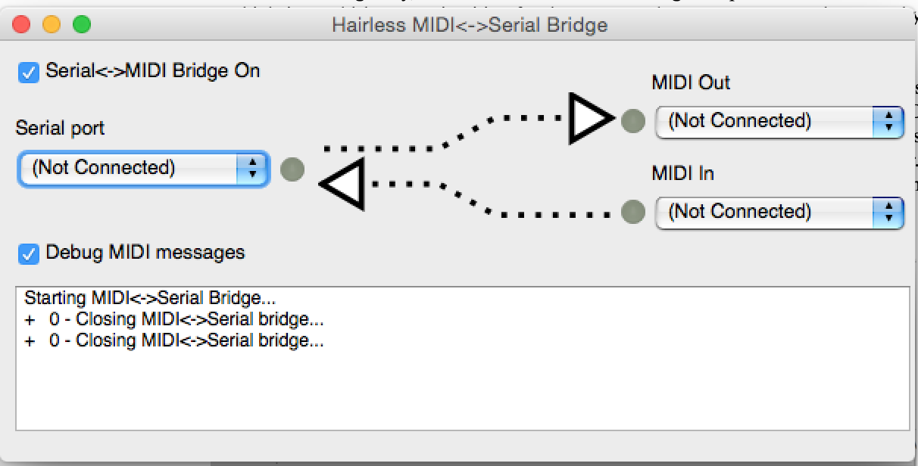
Hairless Midiserial - The midi converter software

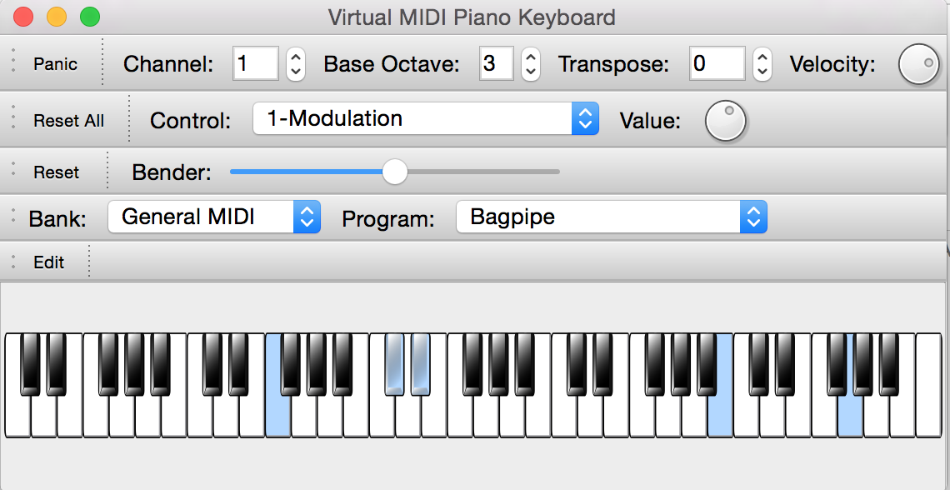
Vmpk - The midi synthesizer
2. Tutorial Mode
To enter Tutorial Mode, we provided a button, which, when pressed, switches out of free play mode and into a tutorial for one of three implemented songs. One press of the button will start a tutorial for “Twinkle Twinkle Little Star”, two presses will begin a verse of “Hedwig’s Song” (better known as the Harry Potter theme), and three will begin the hook for “One Love” by Bob Marley. These songs were selected because they can be simplified into only major C-scale notes (which our strings represent C to B).
Essentially, Tutorial Mode consists of the proper laser for each note turning on, waiting for the user to interrupt, then playing the note, turning off the laser, and moving onto the next note in the song. To make it more child friendly and less clumsy, we disabled all other notes when waiting for a note to be played. There were some difficulties with lasers not turning off, long delays between notes, and not being able to switch modes mid-song, which were all addressed on the backend, and the product works very well now! Upon completion of one of the songs, the harp returns to Free Play Mode.
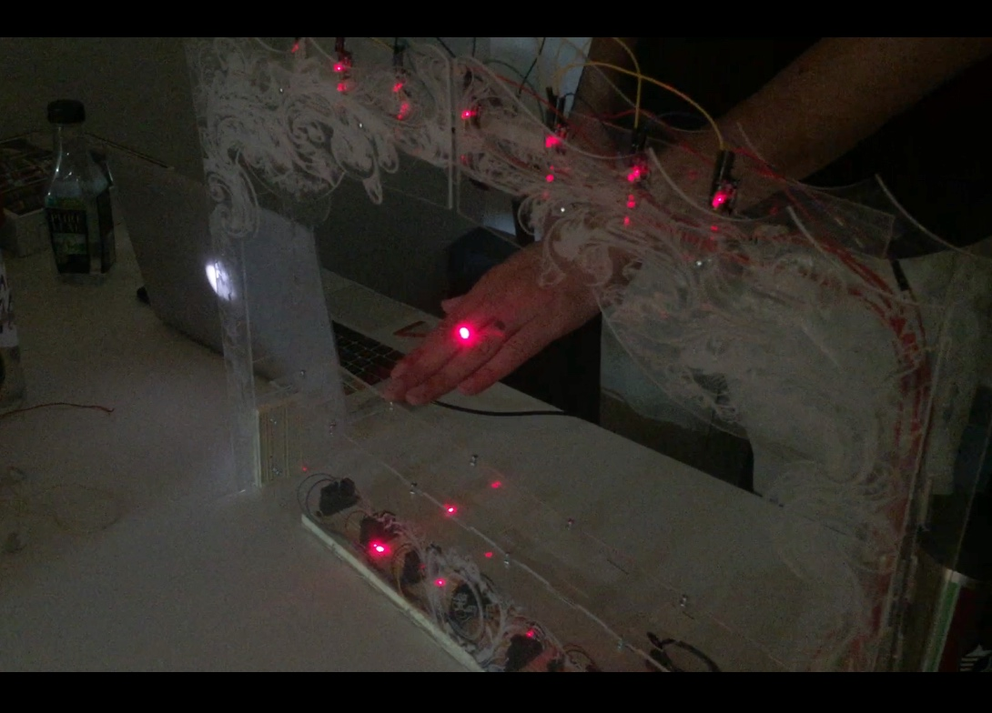
Final Prototype being played

3. Frame and Box
The box contains the sensors, breadboard, and wires. Not only will it protect this delicate components, but it will also hold them in place. Because the range sensor will be activated by any object that enters its path it is very important that it remains fixed in its place. There are 7 holes in the lid for each of the 7 sensors and lasers, as well as a small hole in the side to allow wire access for the Arduino photon and the other outer components. Much like our jack in the box project, we laser cut our final casing by making several fitted sides. The range sensors have poor performance within roughly 5 inches of the sensor (similar to the sensors we used in class). We therefore designed the box to be about 5 inches in height to prevent the user from getting within this range. The box was bound together using simple notches as well at t-cuts. Initially, we planned to create a solid box, but found it was easiest to access and adjust the wires and sensors by having a separate top piece (all sides except the bottom) fixed solidly together and use notches to stabilize this over the bottom piece (which the breadboard was attached to). This allowed for adjustments while still protecting the inner parts. We noted in our presentation that our users had a tendency to smack the top for the box (with a fair amount of force) when playing the harp so incorporating this safety precaution was an essential feature.

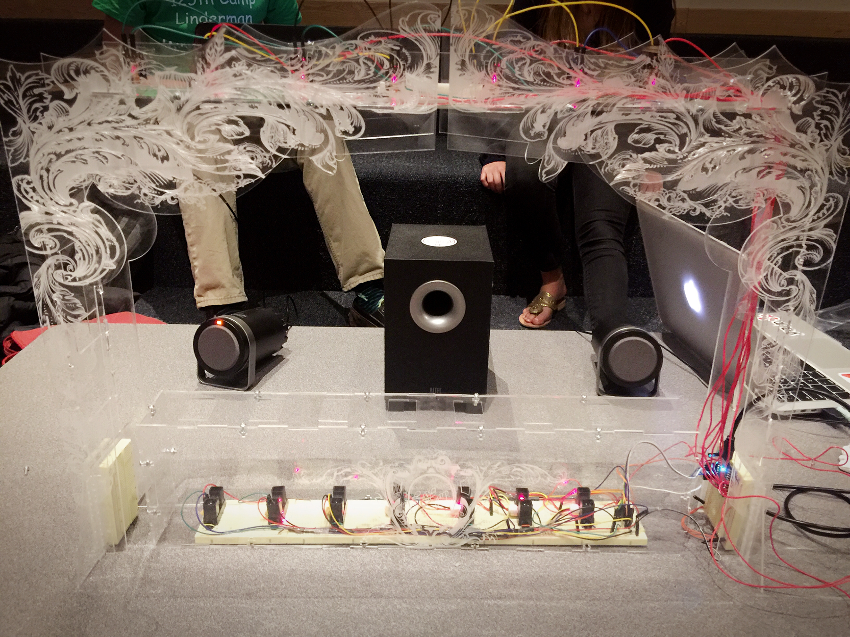
Final Prototype

The frame serves two basic purposes: to limit the motion of the user to a distance the range sensor can detect, and to hold the lasers. The sensors we are using are effective up to a distance of about 40 cm. Therefore the final design of the frame is roughly this height, in relation to the top of our box casing (it should be noted that our low fidelity prototype had a frame smaller than this for convenience and stability purposes with the cardboard). Initially, we planned to house the lasers in the box as well in order to consolidate the wires and also provide protection. However, we discovered that pointing the lasers directly upward could be potentially harmful to the user, particularly if the lasers were intense. Therefore, we decided to move the lasers to the top of the frame and pointed them downward toward the range sensors. This presented two small challenges: connecting the lasers to the arduino (which is located at the base of the frame with the breadboards) and ensuring lasers did not activate the range sensor. To solve these we fixed the lasers to a piece of acrylic that was perpendicularly attached to the top of the frame and ran wires through the side of the frame from the arduino to the top. When attaching the lasers, we made sure to angle the beam so that its was directed just shy of the sensor. Our final design was at first unstable. To prevent this, we added additional braces between the front and back of the frame, on the right and left side. Additionally, we created notched pieces that we glued to the frame base and sides (which created a more stable base).

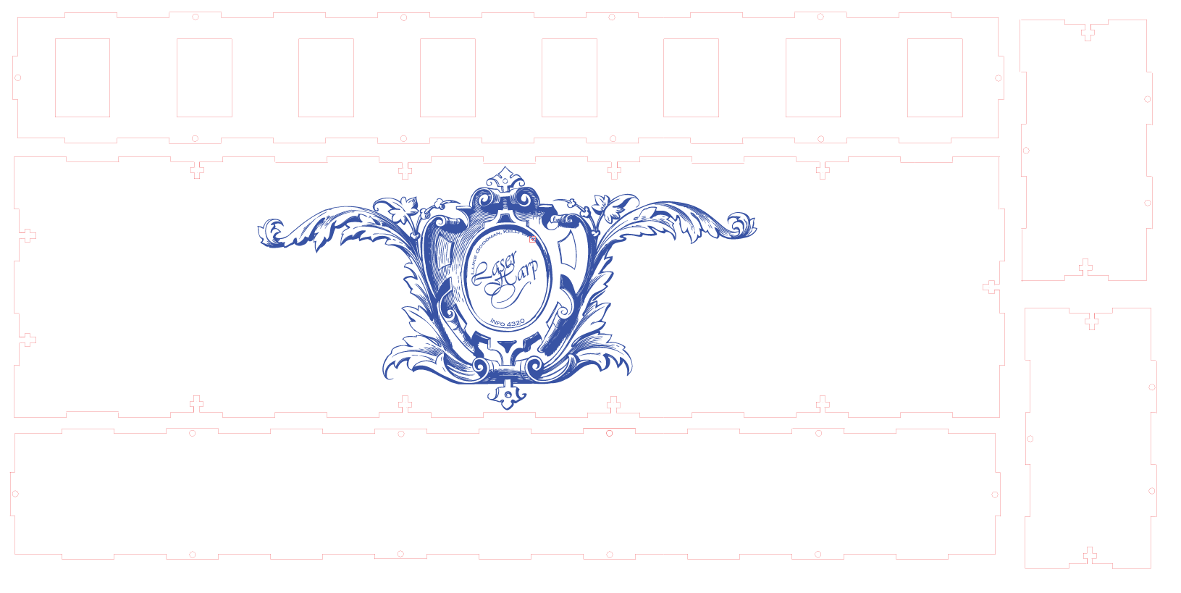
Initial Design of the Box (adjustments later made to the top and one side)

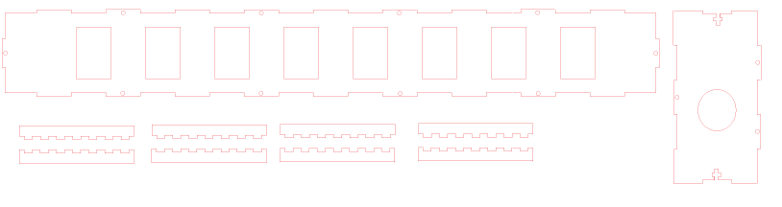
Adjustment made to top piece and side piece. Notch pieces used to fortify harp base to frame

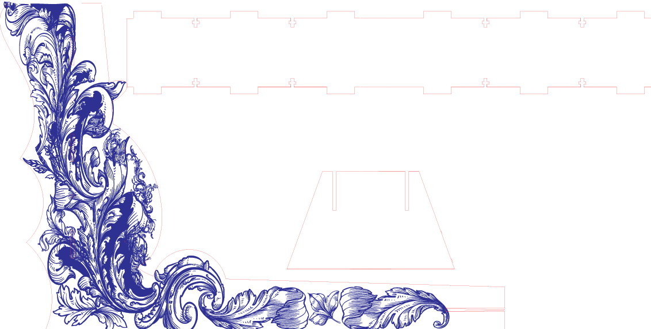
Design of harp frame

FUTURE WORK
If our group were to pursue this further, we would like to add modulation of notes based on the specific point of interruption in a given string. This would make the instrument more dynamic and allow for music to be played outside of the simple C-major scale. There is a slight delay on note interruption, which can make playing the instrument a bit choppy, so streamlining our code or implementing higher quality sensors might be of interest as well. Improvement of the alignment of lasers with perhaps purchased or 3D-printed mounts would also make the harp more aesthetically pleasing and increase visibility of our lasers. We would also like to polish the songs we have implemented and add more to our tutorial playlist.
Outside of these small fixes, we originally were and still somewhat are interested in the creation of a larger scale version, in which the lasers are directed continuously and visibly (stronger/different frequency lasers) upward, with a larger range of interruption (more powerful range sensors or light sensors). We would also want to be able to create cross-instrument synthesized beats with the different strings. We currently can change instruments using our MIDI interface, but found that assigning a new instrument to every string caused an overload every once in a while, so we are interested in exploring how to overcome that.

REFERENCES
- "AIRduino Guitar." YouTube. Gussoh, 14 Oct. 2009. Web. 28 Feb. 2016. <https://www.youtube.com/watch?v=sJxM18o9EPs>.
- Ball, Chris. "Quick Arduino MIDI Harp." Instructables.com. N.p., n.d. Web. 28 Feb. 2016. <http://www.instructables.com/id/Quick-Arduino-MIDI-Laser-Harp/step7/Finished/>.
- Ball, Chris. "Quick Arduino MIDI Laser Harp." Instructables.com. N.p., n.d. Web. 28 Feb. 2016. <http://www.instructables.com/id/Quick-Arduino-MIDI-Laser-Harp/>.
- "Beamz." Beamz.com. Beamz, Inc., n.d. Web. 28 Feb. 2016. <http://www.thebeamz.com/>.
- Bonnie. "Illumaphone: Light-based Musical Instrument with Arduino." Instructables. N.p., n.d. Web. 28 Feb. 2016. <http://www.instructables.com/id/Illumaphone-Light-based-Electronic-Musical-Instrum/>.
- "Getting Started with the VL6180X Explorer Kit." YouTube. STMicroelectronics NV, 23 Oct. 2014. Web. 28 Feb. 2016. <https://www.youtube.com/watch?v=g_EzdKc9oQg>.
- Hobley, Steve. "Laser Harp 2010." StevenHobley.com. N.p., 2010. Web. 28 Feb. 2016. <http://www.stephenhobley.com/blog/laser-harp-2009/>.
- "Laser Harp Demonstration." YouTube. WaxApul, n.d. Web. 28 Feb. 2016. <https://www.youtube.com/watch?v=Xw_L-GN4V5M>.
- Lee, Joel. "6 Musical Projects for Arduino Beginners." MakeUseOf. N.p., 13 Aug. 2015. Web. 28 Feb. 2016. <http://www.makeuseof.com/tag/musical-projects-arduino-beginners/>.
- "A Look at Beamz - A Musical Instrument for Everyone." YouTube. Coolsmartphone Videos, 14 May 2015. Web. 28 Feb. 2016. <https://www.youtube.com/watch?v=0z50TE9eDak>.
- "MIDI for the Arduino - Circuit Analysis." YouTube. Notes and Volts, 29 Nov. 2014. Web. 28 Feb. 2016. <https://www.youtube.com/watch?v=0L7WAMFWSgY>.
- Morriseau, Franck. "Laser Harp." Laser Harp. N.p., n.d. Web. 28 Feb. 2016. <http://www.harpelaser.com/>.
- Reynolds, Evan. "Build a Two-Octave Laser Harp." Makezine. Make, n.d. Web. 28 Feb. 2016. <http://makezine.com/projects/build-two-octave-laser-harp/>.
- Zanella, Lucas. "Coke Piano and Launchpad Made with Arduino." YouTube. N.p., 2013 Aug. 2013. Web. 28 Feb. 2016. <https://www.youtube.com/watch?time_continue=140&v=Ttm62RBdOuo>.

